Creating a Data Delivery Stream for both customer.csv and order.csv to process our data .

1. Create a delivery system as shown in the pictures below

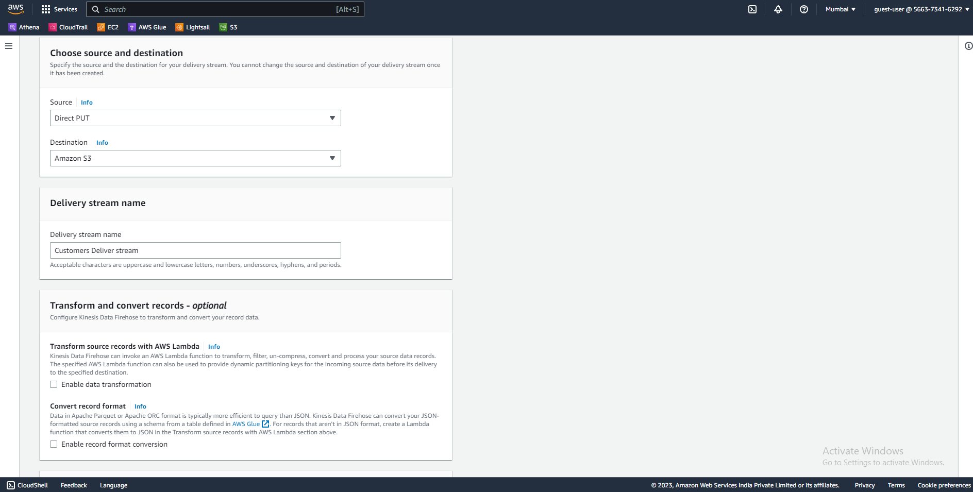

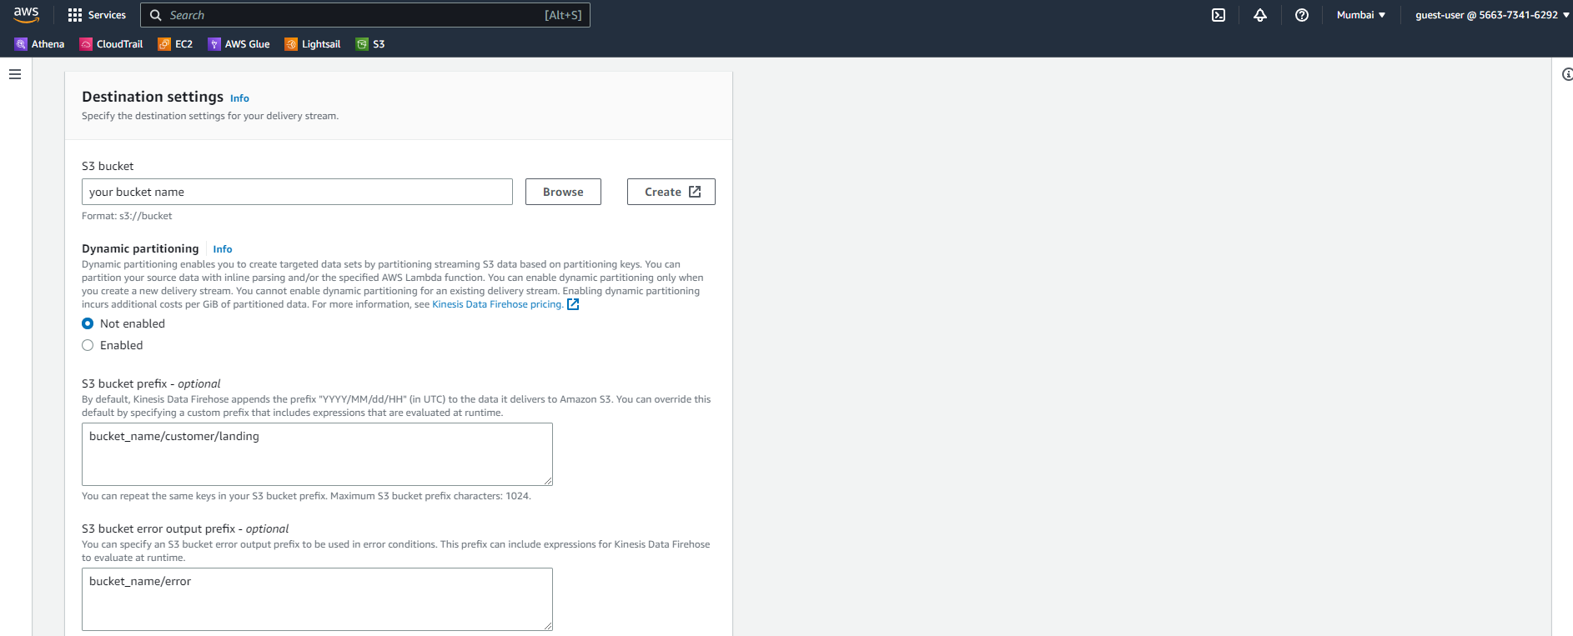

Do the same for creating you Orders data Delivery stream.

1. IMPORTANT STEP.   
     
   After your kinesis delivery is up and running for both the data.   
   We will connect with our EC2 instance using the given connection command in the Connect section of your instance.   
   command to connect with EC2 instance   
   “ ssh -i "kinesis.pem" [ec2-user@ec2-3-110-147-192.ap-south-1.compute.amazonaws.com](mailto:ec2-user@ec2-3-110-147-192.ap-south-1.compute.amazonaws.com) ”  
     
   After that Type these command in order to install KINESIS AGENT INTO YOUR EC2 instance.
2. Command use for installing AWS Kinesis Agent
   1. **sudo yum install -y aws-kinesis-agent**
   2. **after this type the following commands**
   3. **cd /etc/aws-kinesis**
   4. **ls**
   5. **sudo vim agent.json**

**THEN PASTE THE FOLLOWING format in it make sure to change the name as per your kinesis delivery names**

**{**

**"cloudwatch.emitMetrics": true,**

**"firehose.endpoint": "firehose.ap-south-1.amazonaws.com",**

**"flows": [**

**{**

**"filePattern": "/tmp/orders.csv*",**

**"deliveryStream": "your_stream_name",**

**"initialPosition": "START_OF_FILE"**

**},**

**{**

**"filePattern": "/tmp/customers.csv*",**

**"deliveryStream": ""your_stream_name",",**

**"initialPosition": "START_OF_FILE"**

**}**

**]**

**}  
  
SAVE and exit the vim setup**

**INSERT THE DATA USING the VI command**

* **Command to enter the orders data** 
  + **vi orders.csv #Copy paste the data from the csv file**
* **Commend to enter the customers data** 
  + **vi customers.csv #copy paste the data from the csv file**

1. Command to start AWS kinesis Agent
   1. **sudo service aws-kinesis-agent start**
2. Command to stop AWS Kinesis Agent
   1. **sudo service aws-kinesis-agent stop**
3. Command to get the status of AWS Kinesis Agent
   1. **sudo service aws-kinesis-agent status**
4. Command for reading logs of AWS Kinesis Agent
   1. **tail -f /var/log/aws-kinesis-agent/aws-kinesis-agent.log**
5. Path where configuration file of AWS Kinesis Agent is placed
   1. **/etc/aws-kinesis**